# Power BI Assignment – 2

Name: T .Vivek

Connect to the Store Sales Data and do the following: -

* Remove all the blank rows.
* Update the column header if they are not updated
* Create a text table and show the sales in terms of Customers, Product Category & Regions

Step1: Connecting data source to Power BI and selecting the orders table and transforming data

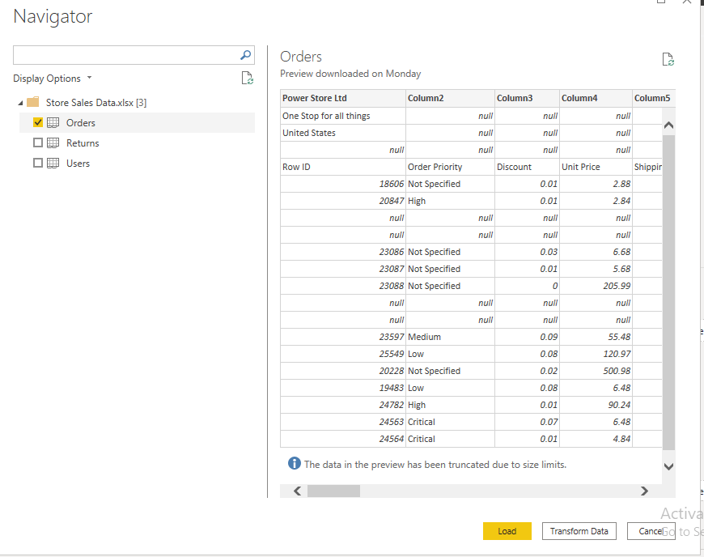

After clicking the “Transform data”. Data appears in power query editor. Here we need to do necessary transformations

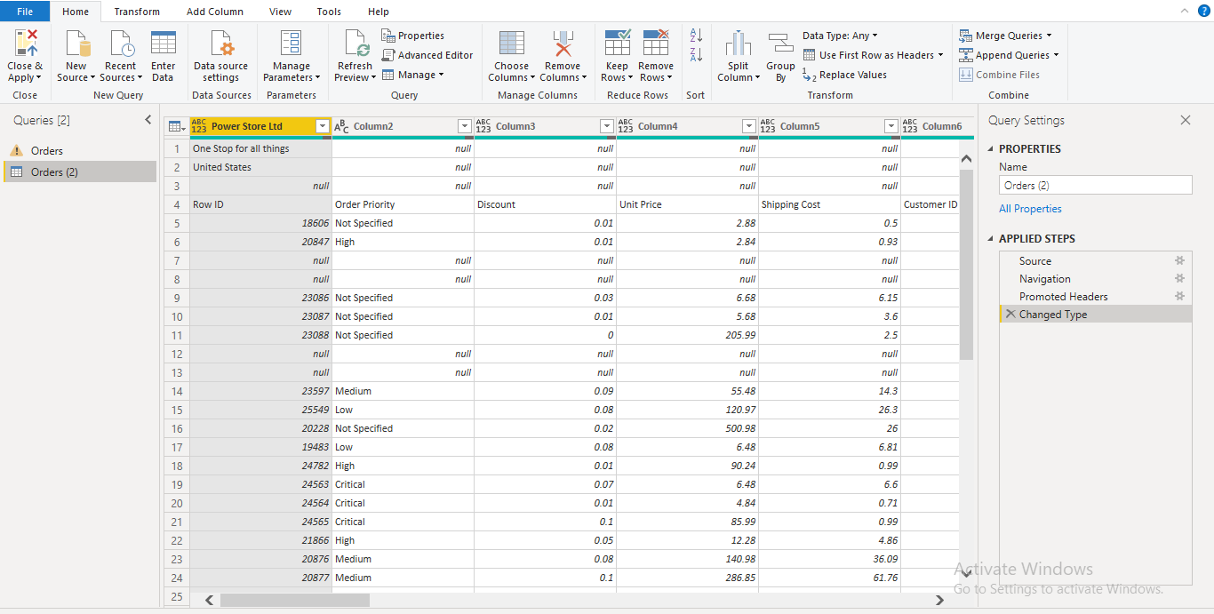

In above data we can see null values , so we need remove those using “remove rows” under the Home tab.

**Removing the blank rows.**

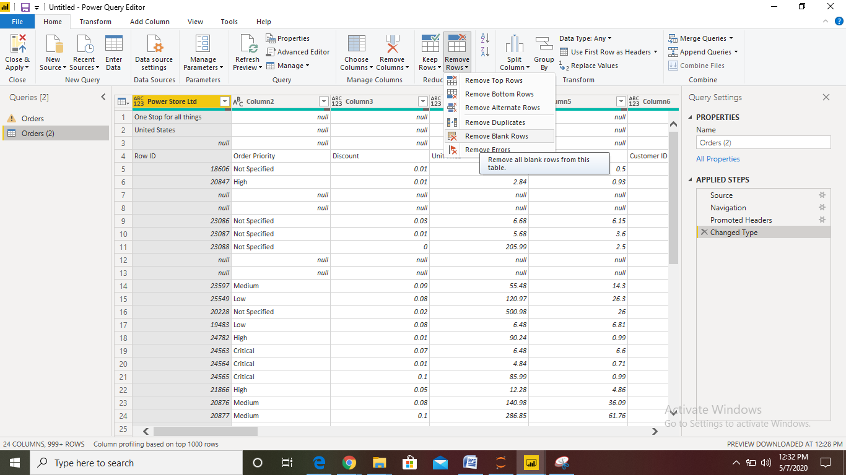

After removing Null rows I am seeing the below data in query editor.

I am seeing first 2 rows contains some nulls & values in cells so we need to remove using “remove top rows”

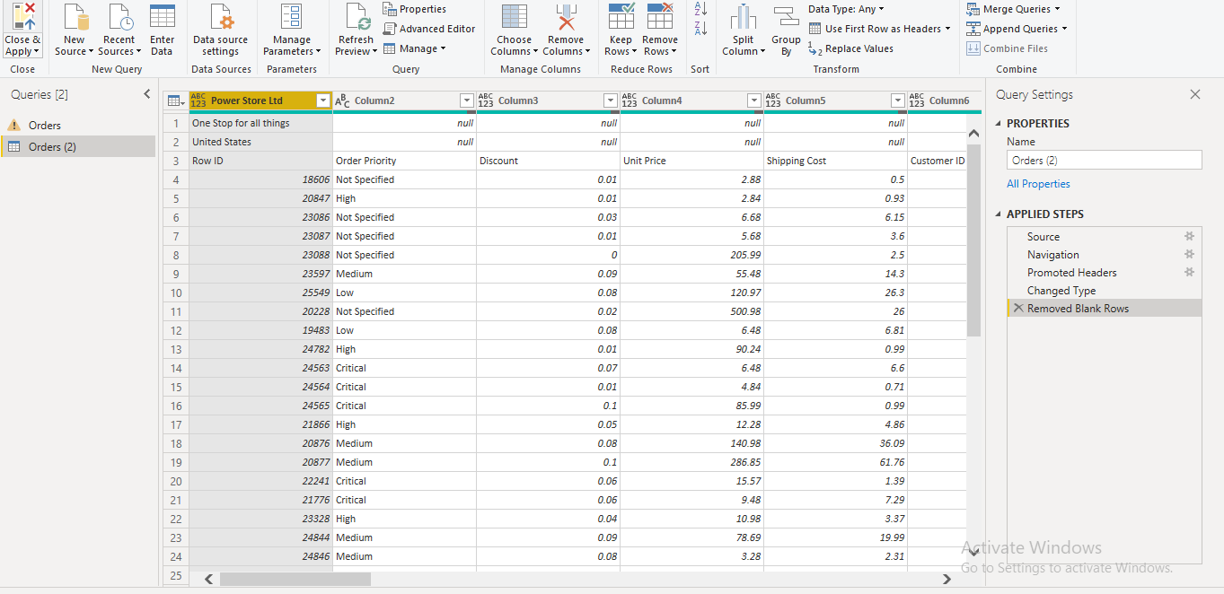

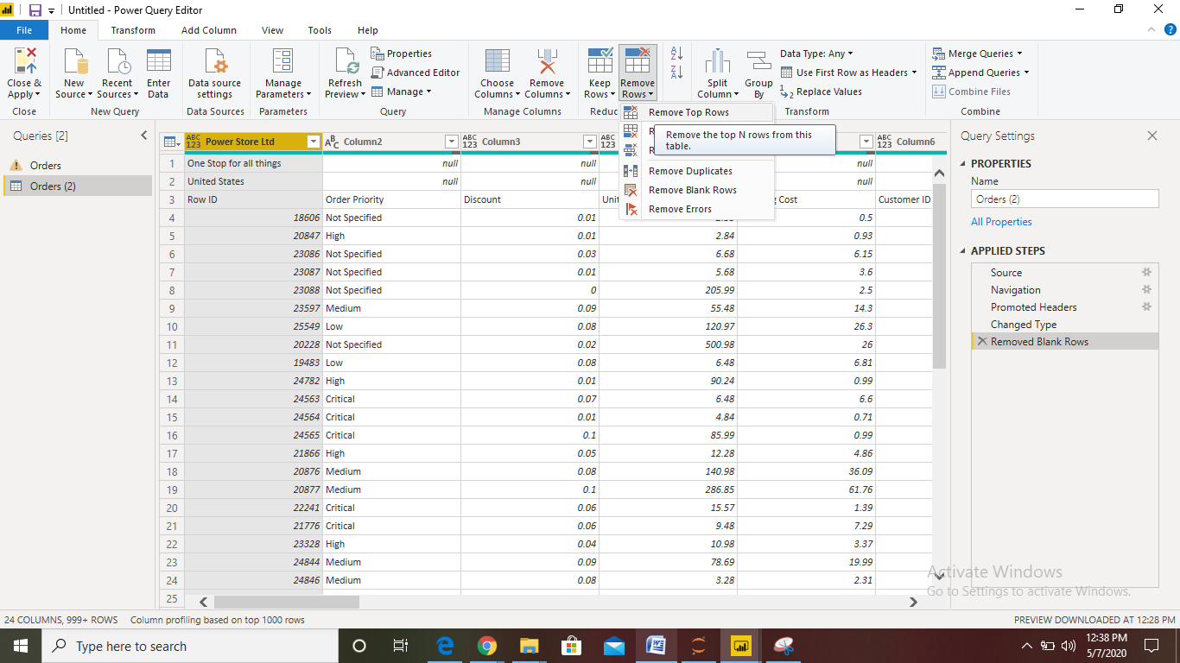

Removed top 2 rows:

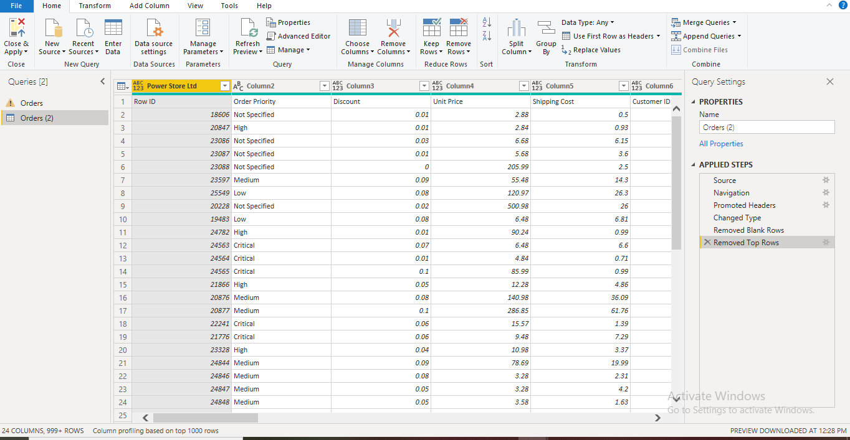

Step3: Need to update the Coolum header using “Use First row as Column hear” in right side-ribbon of query editor”

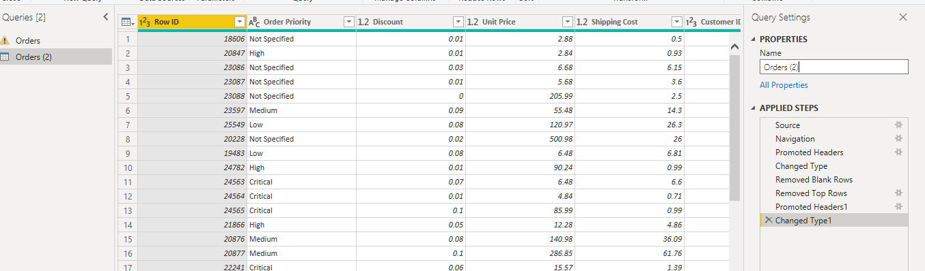

Next Created Dashboard

• Create a line and Clustered Column Chart showing the Sales and Discount as per the State or Province − Format the bars and line with different colors − Which state has the highest sales in terms Technology

Ans: Cenral State 1M States

• Create a Donut Chart showing sales in terms of Product category

• Create a Slicer and show the regions in dropdown. See how all the visuals mentioned above behaving when a particular region is selected.

DashBoard:

**When selecting all the states:**

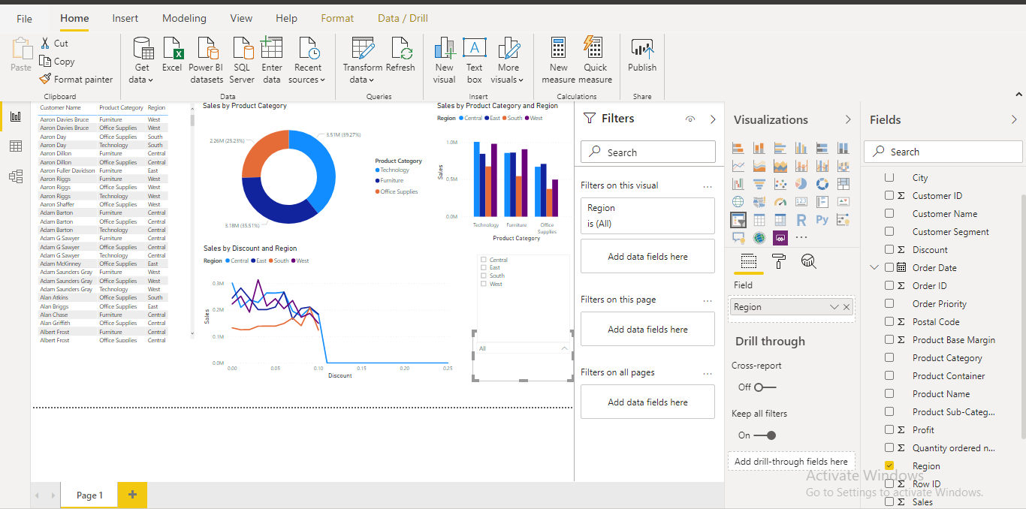

Selecting the central:

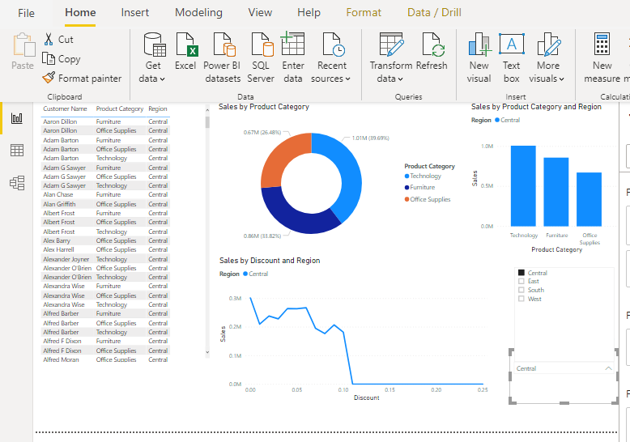

When selecting East region:

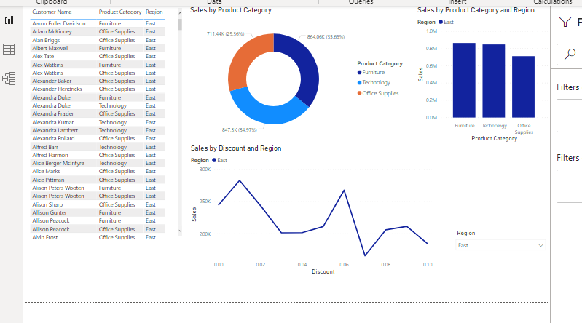

When Selecting “South region”

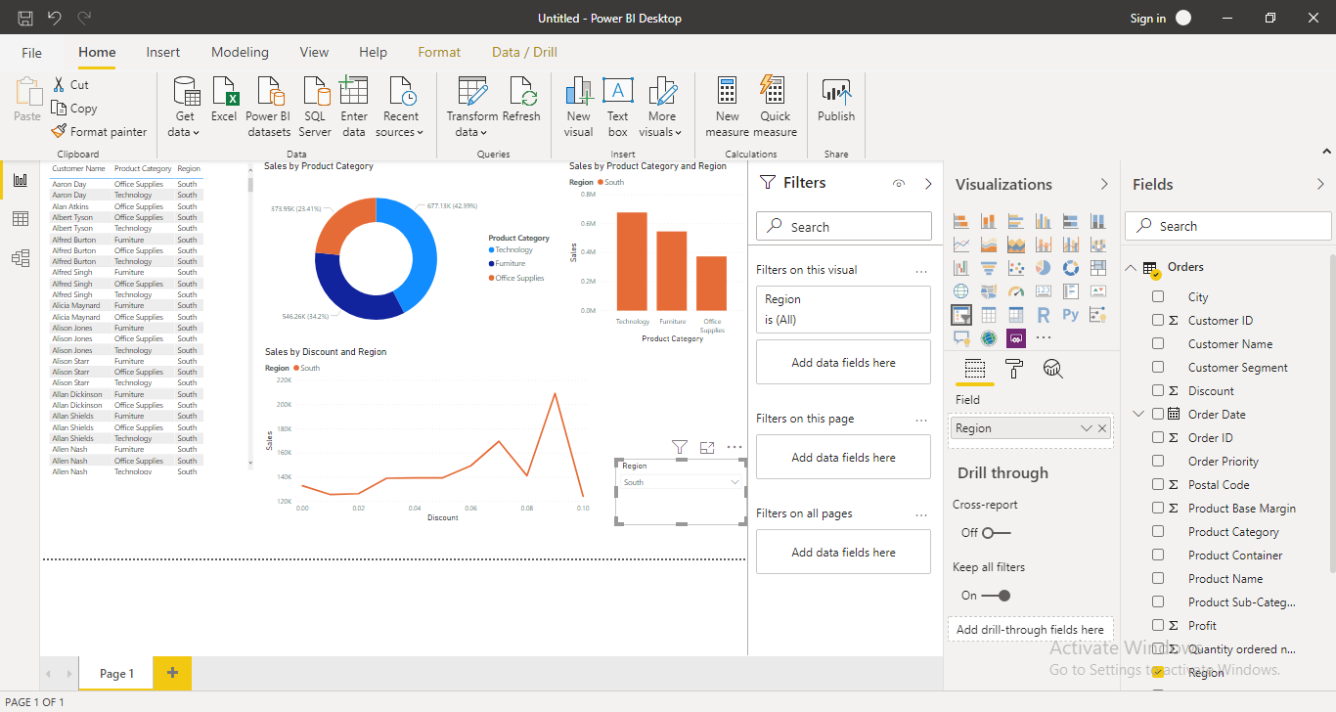

When Selecting “westregion”

